Creating the Repository
I began by creating a new empty GitHub repository named alimaekaya-sit722 as instructed. I followed the official GitHub guide on how to create a new repository, ensuring that it was initialized without a README, license, or .gitignore. This prepared a clean workspace to connect with my local project later.
Setting up the Local Repository
On my local machine, I created a new project folder and used the command line instructions provided by GitHub after repository creation. These included initializing the folder as a Git repository, adding the remote origin, and confirming the connection. This ensured that my local project and the remote repository were linked correctly.

Downloading and Uploading Project Code
I then downloaded the provided Task 10.2D resource code, unzipped it, and placed the files into my local project folder. Once the code was in place, I added all files to Git, committed them with a clear message, and pushed the initial version to the remote repository on GitHub. At this point, the project code was version-controlled and available online.
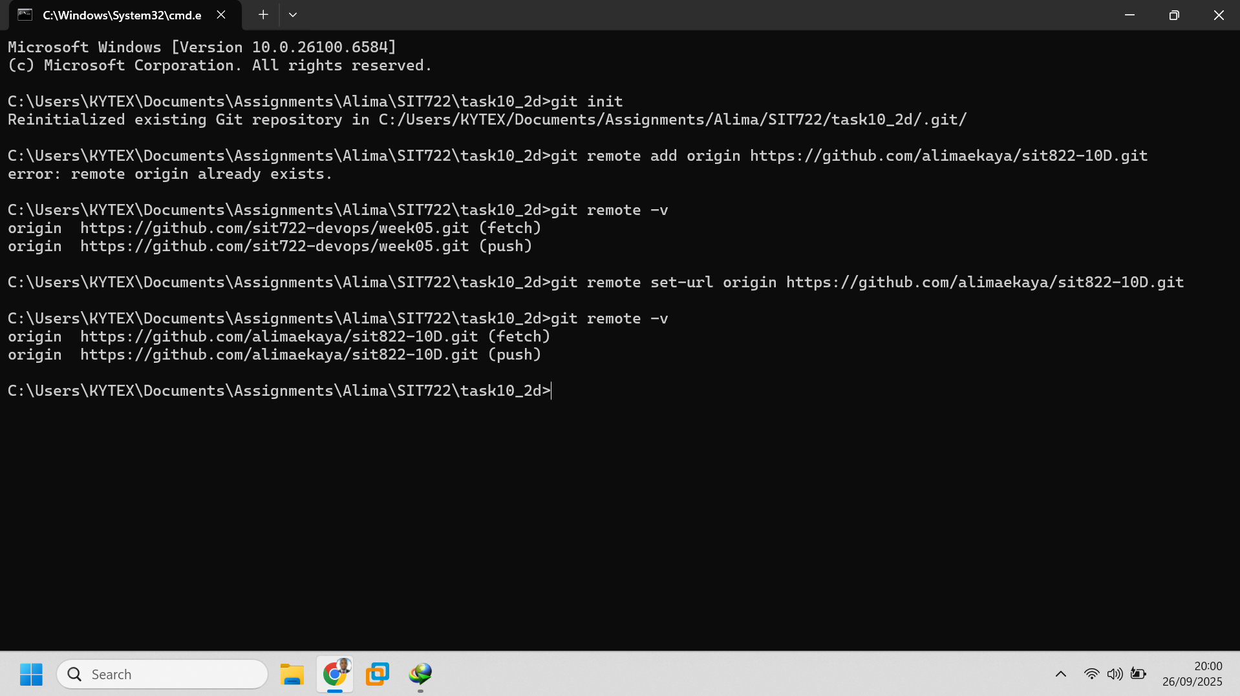
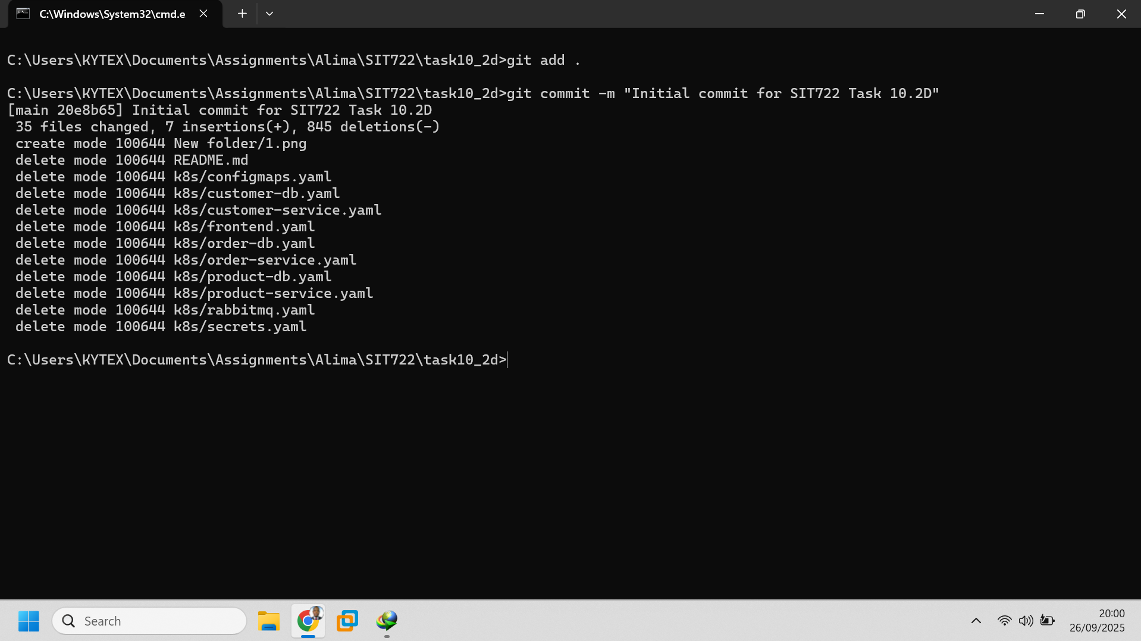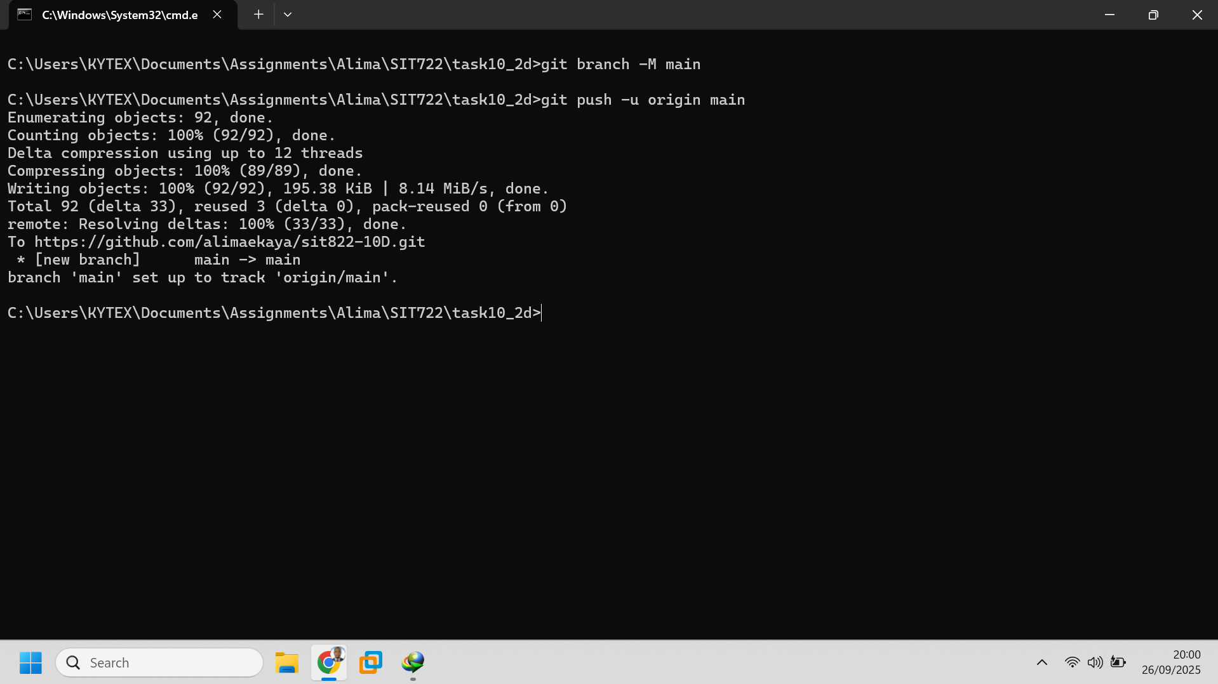
Creating the CI Pipeline (Stage 1)
Next, I designed and implemented a complete CI pipeline using GitHub Actions. The pipeline was configured to trigger automatically whenever code was pushed to the testing branch. Its main purpose was to run build steps and execute tests on the code. Only if all tests passed successfully would the pipeline proceed to build a Docker image and upload it to DockerHub. This setup ensured that only tested and verified code could move forward.
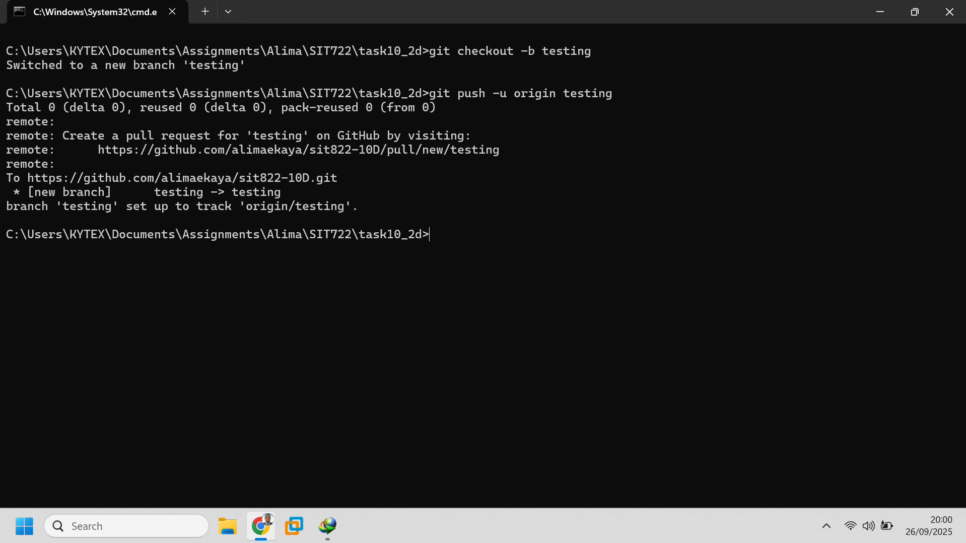
Staging Deployment (Stage 2)
Once the image was uploaded, the pipeline was extended to create a temporary staging environment. Using workflow actions, the Docker image was deployed in this staging environment, allowing me to run manual or basic acceptance tests. After confirming that the system worked as expected, the staging environment was destroyed to save resources. This step acted as a controlled checkpoint before production deployment.
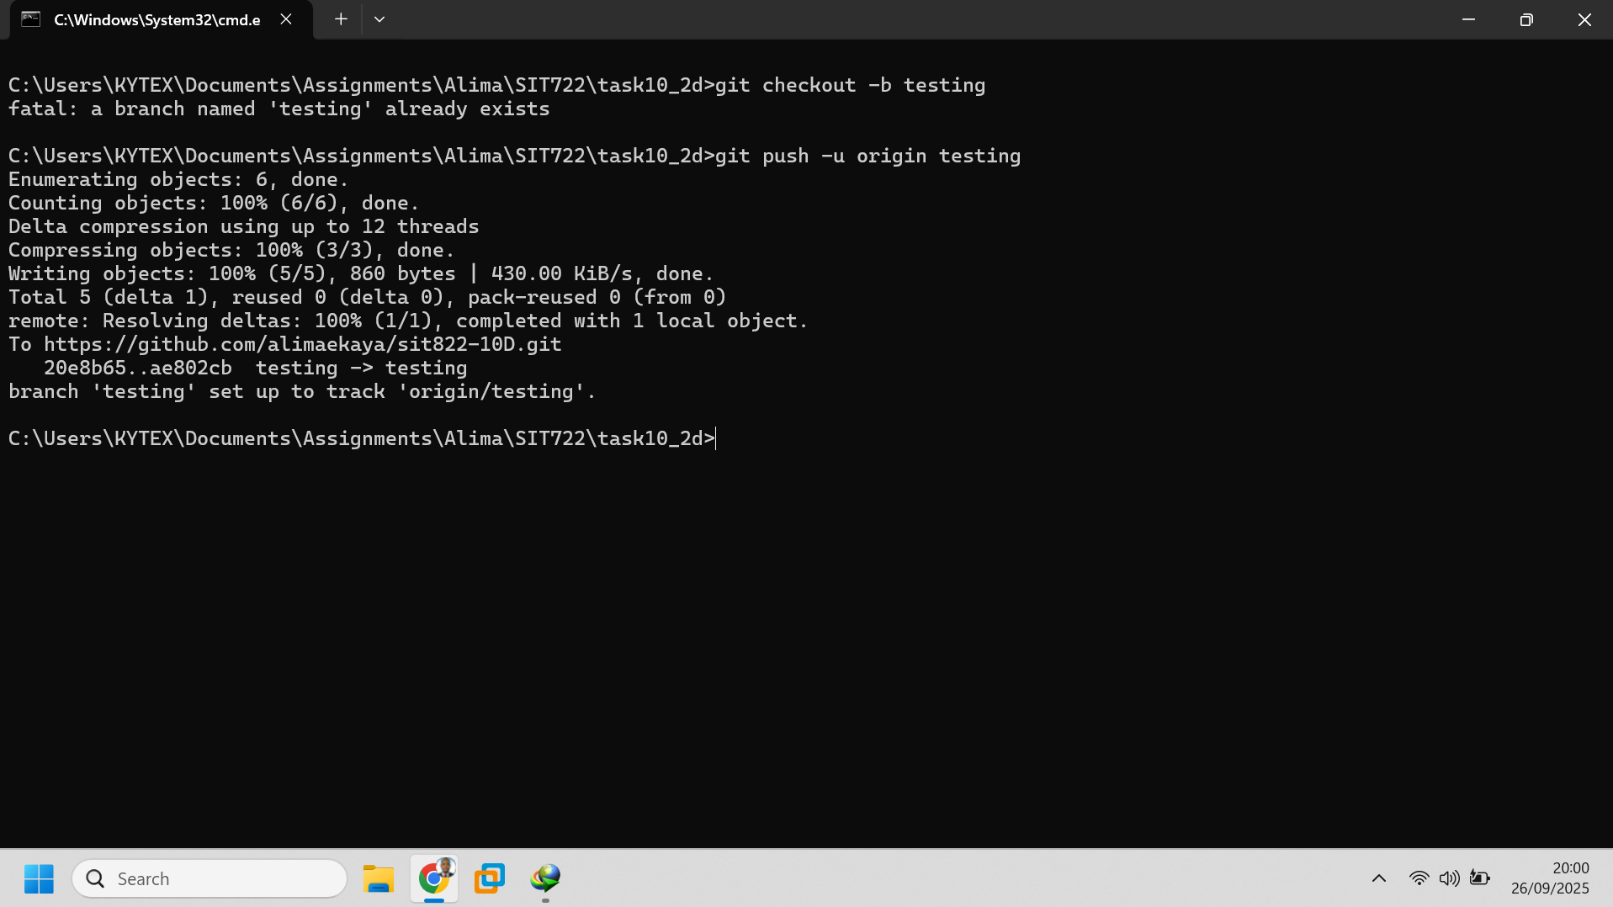
Production Deployment
Finally, I merged the tested code from the testing branch into the main branch through a pull request. This merge action triggered the production deployment pipeline, which deployed the latest stable Docker image to the existing production environment. This ensured that only thoroughly tested and approved code reached production, supporting a reliable and secure DevOps workflow.
